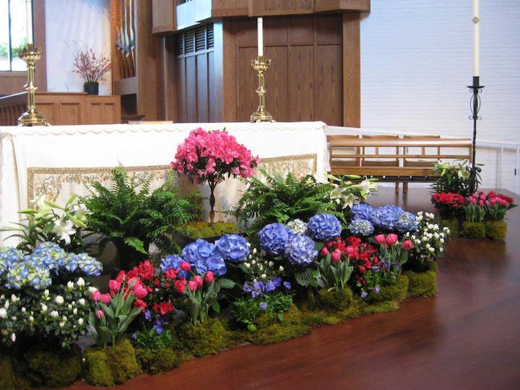

Morning Prayer: Rite Two
The Sixth Sunday of Easter
May 9, 2021
10:00 am
The People are invited to read the words in bold. While we’re online, these words will be led by someone on screen so that you can read and pray with them. No matter where you are, joining in this worship service is a form of prayer that connects you to God and to each other. Find a comfortable place to sit. Kneel or stand for the prayers if you’d like. Whenever two or three are gathered, even virtually, Scripture reminds us that Jesus is present among us.

+ T H E W O R D O F G O D +

Prelude Felix Mendelssohn
Allegretto from Sonata No. 4 in Bb Major

Opening Hymn 209 St. Botolph
We walk by faith, and not by sight
The People are invited to sing at home.
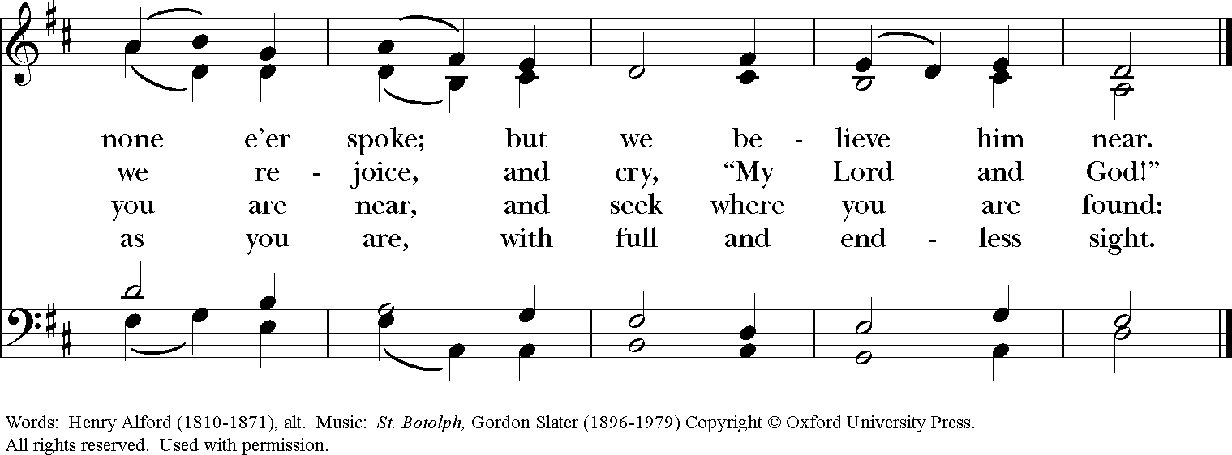
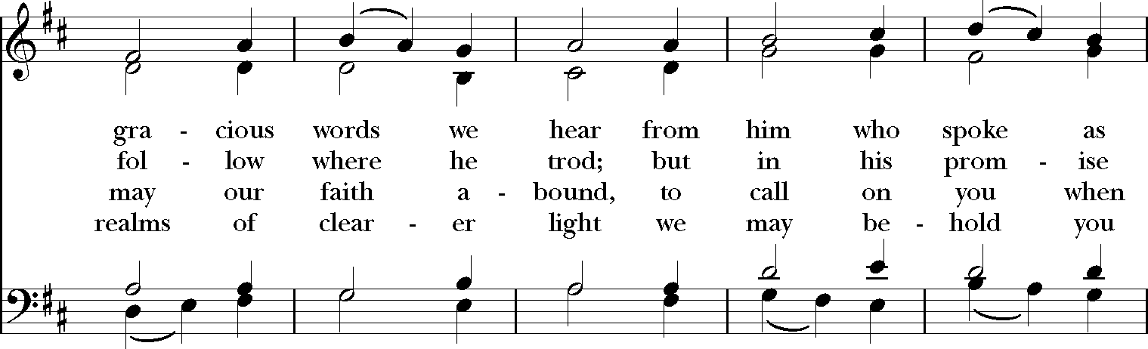
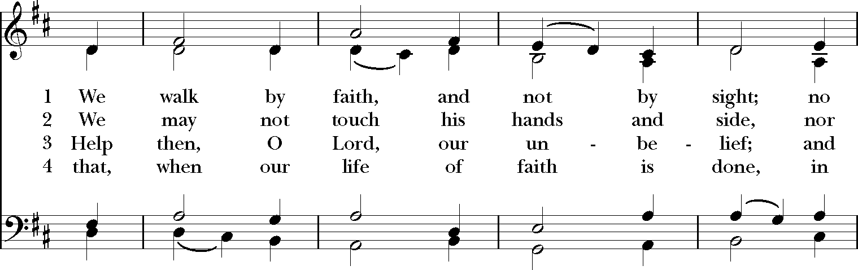
Officiant Alleluia! Christ is risen!
People The Lord is risen indeed! Alleluia!

The Officiant continues
If then you have been raised with Christ, seek the things that are above, where Christ is, seated at the right hand of God.
Colossians 3:1

Confession of Sin
The Officiant says
Let us confess our sins against God and our neighbor.

The Officiant and People say together
Most merciful God,
we confess that we have sinned against you
in thought, word, and deed,
by what we have done,
and by what we have left undone.
We have not loved you with our whole heart;
we have not loved our neighbors as ourselves.
We are truly sorry and we humbly repent.
For the sake of your Son Jesus Christ,
have mercy on us and forgive us;
that we may delight in your will,
and walk in your ways,
to the glory of your Name. Amen.

The Priest says
Almighty God have mercy on you, forgive you all your sins through our Lord Jesus Christ, strengthen you in all goodness, and by the power of the Holy Spirit keep you in eternal life. Amen.

The Invitatory and Psalter
Officiant Lord, open our lips.
People And our mouth shall proclaim your praise.

Officiant People
Alleluia. The Lord is risen indeed: Come let us adore him. Alleluia.

Officiant and People say together
Alleluia. Christ our Passover has been sacrificed for us; *
therefore let us keep the feast,
Not with old leaven, the leaven of malice and evil, *
but with the unleavened bread of sincerity and truth. Alleluia.
Christ being raised from the dead will never die again; *
death no longer has dominion over him.
The death that he died, he died to sin, once for all; *
but the life he lives, he lives to God.
So also consider yourselves dead to sin, *
and alive to God in Jesus Christ our Lord. Alleluia.
Christ has been raised from the dead, *
the first fruits of those who have fallen asleep.
For since by a man came death, * by a man has come also the resurrection of the dead. For as in Adam all die, *
so in Christ shall all be made alive. Alleluia.
Officiant People
Alleluia. The Lord is risen indeed: Come let us adore him. Alleluia.

Psalm 98
The Choir chants the Psalm. The People are invited to sing at home.
¹ Sing to the Lord a new song, *
for he has done marvelous things.

² With his right hand and his holy arm *
has he won for himself the victory.

³ The Lord has made known his victory; *
his righteousness has he openly shown in the sight of the nations.

⁴ He remembers his mercy and faithfulness to the house of Israel, *
and all the ends of the earth have seen the victory of our God.

⁵ Shout with joy to the Lord, all you lands; *
lift up your voice, rejoice, and sing.

⁶ Sing to the Lord with the harp, *
with the harp and the voice of song.

⁷ With trumpets and the sound of the horn *
shout with joy before the King, the Lord.

⁸ Let the sea make a noise and all that is in it, *
the lands and those who dwell therein.

⁹ Let the rivers clap their hands, *
and let the hills ring out with joy before the Lord,
when he comes to judge the earth.

¹⁰ In righteousness shall he judge the world *
and the peoples with equity.

The First Lesson Acts 10:44-48
While Peter was still speaking, the Holy Spirit fell upon all who heard the word. The circumcised believers who had come with Peter were astounded that the gift of the Holy Spirit had been poured out even on the Gentiles, for they heard them speaking in tongues and extolling God. Then Peter said, "Can anyone withhold the water for baptizing these people who have received the Holy Spirit just as we have?" So he ordered them to be baptized in the name of Jesus Christ. Then they invited him to stay for several days.
Lector The Word of the Lord.
People Thanks be to God.

Canticle 8 The Song of Moses
Officiant and People say together
I will sing to the Lord, for he is lofty and uplifted; *
the horse and its rider has he hurled into the sea.
The Lord is my strength and my refuge; *
the Lord has become my Savior.
This is my God and I will praise him, *
the God of my people and I will exalt him.
The Lord is a mighty warrior; * Yahweh is his Name.
The chariots of Pharaoh and his army has he hurled into the sea; *
the finest of those who bear armor have been
drowned in the Red Sea.
The fathomless deep has overwhelmed them; *
they sank into the depths like a stone.
Your right hand, O Lord, is glorious in might; *
your right hand, O Lord, has overthrown the enemy.
Who can be compared with you, O Lord, among the gods? *
who is like you, glorious in holiness,
awesome in renown, and worker of wonders?
You stretched forth your right hand; *
the earth swallowed them up.
With your constant love you led the people you redeemed; *
with your might you brought them in safety to your holy dwelling.
You will bring them in and plant them *
on the mount of your possession,
The resting-place you have made for yourself, O Lord, *
the sanctuary, O Lord, that your hand has established.
The Lord shall reign * for ever and for ever.
Glory to the Father, and to the Son, and to the Holy Spirit: *
as it was in the beginning, is now, and will be for ever. Amen.

The Second Lesson 1 John 5:1-6
Everyone who believes that Jesus is the Christ has been born of God, and everyone who loves the parent loves the child. By this we know that we love the children of God, when we love God and obey his commandments. For the love of God is this, that we obey his commandments. And his commandments are not burdensome, for whatever is born of God conquers the world. And this is the victory that conquers the world, our faith. Who is it that conquers the world but the one who believes that Jesus is the Son of God?
This is the one who came by water and blood, Jesus Christ, not with the water only but with the water and the blood. And the Spirit is the one that testifies, for the Spirit is the truth.
Lector The Word of the Lord.
People Thanks be to God.

Canticle S A Song of Our True Nature
Officiant and People say together
Christ revealed our frailty and our falling, *
our trespasses and our humiliations.
Christ also revealed his blessed power, *
his blessed wisdom and love.
He protects us as tenderly and as sweetly
when we are in greatest need; *
he raises us in spirit
and turns everything to glory and joy without ending.
God is the ground and the substance, the very essence of nature; *
God is the true father and mother of natures.
We are all bound to God by nature, *
and we are all bound to God by grace.
And this grace is for all the world, *
because it is our precious mother, Christ.
For this fair nature was prepared by Christ
for the honor and nobility of all, *
and for the joy and bliss of salvation.

The Third Lesson John 15:9-17
Jesus said to his disciples, “As the Father has loved me, so I have loved you; abide in my love. If you keep my commandments, you will abide in my love, just as I have kept my Father’s commandments and abide in his love. I have said these things to you so that my joy may be in you, and that your joy may be complete.
“This is my commandment, that you love one another as I have loved you. No one has greater love than this, to lay down one’s life for one’s friends. You are my friends if you do what I command you. I do not call you servants any longer, because the servant does not know what the master is doing; but I have called you friends, because I have made known to you everything that I have heard from my Father. You did not choose me but I chose you. And I appointed you to go and bear fruit, fruit that will last, so that the Father will give you whatever you ask him in my name. I am giving you these commands so that you may love one another.”
Lector The Word of the Lord.
People Thanks be to God.

The Sermon The Rev. Dr. Molly James

The Apostles’ Creed
Officiant and People say together
I believe in God, the Father almighty,
creator of heaven and earth.
I believe in Jesus Christ, his only Son, our Lord.
He was conceived by the power of the Holy Spirit
and born of the Virgin Mary.
He suffered under Pontius Pilate,
was crucified, died, and was buried.
He descended to the dead.
On the third day he rose again.
He ascended into heaven,
and is seated at the right hand of the Father.
He will come again to judge the living and the dead.
I believe in the Holy Spirit,
the holy catholic Church,
the communion of saints,
the forgiveness of sins,
the resurrection of the body,
and the life everlasting Amen.

The Prayers
Officiant The Lord be with you.
People And also with you.
Officiant Let us pray.

Officiant and People say together
Our Father, who art in heaven,
hallowed be thy Name,
thy kingdom come, thy will be done,
on earth as it is in heaven.
Give us this day our daily bread.
And forgive us our trespasses,
as we forgive those who trespass against us.
And lead us not into temptation, but deliver us from evil.
For thine is the kingdom, and the power, and the glory,
for ever and ever. Amen.

V. Save your people, Lord, and bless your inheritance;
R. Govern and uphold them, now and always.
V. Day by day we bless you;
R. We praise your name for ever.
V. Lord, keep us from all sin today;
R. Have mercy on us, Lord, have mercy.
V. Lord, show us your love and mercy;
R. For we put our trust in you.
V. In you, Lord, is our hope;
R. And we shall never hope in vain.

The Officiant offers a series of prayers, the People respond with the words in bold.
O God, you have prepared for those who love you such good things as surpass our understanding: Pour into our hearts such love towards you, that we, loving you in all things and above all things, may obtain your promises, which exceed all that we can desire; through Jesus Christ our Lord, who lives and reigns with you and the Holy Spirit, one God, for ever and ever. Amen.
We pray for all who are sick and in need of our prayers, especially Courtney, Anderson, Vinny, Ann, Bruce, Melinda, Carolann, Rob, David, Jane, MaryAnn, Roy, Christine, Rich, Nancy, Ken, Dawn, Donnie, David, James, Jeff, Aaron, Michael, Katie, Petra, Doris, Patricia, Frank, Richard, Mary Lou, Charles, Gene, Kathy, Bo, Geoff, Dann and for all those we now name [___________________].

We pray for those we love and see no longer, especially Emily Walke Woodside and Dr. Joseph Hufnagel. We commend to your mercy all who have died in the hope of the resurrection, and we pray that we may share with all your saints in your eternal kingdom.

Gracious and loving God, our only help in time of need: We humbly ask you to behold your people, to relieve and comfort those around the world who are suffering from coronavirus. Look upon them with the eyes of your mercy, comfort them with a sense of your goodness, preserve them from the temptations of the enemy, and give them peace in their affliction. In your good time, restore them to health, and enable them to lead the rest of their lives in favor and to your glory; and grant that they may dwell with you in life everlasting; through Jesus Christ our Lord. Amen.

We pray for our blessings and thanksgivings, especially for the birthdays of
Steffen Nobles, Brad Newtown, Endy Perry and Sam Perry. Amen.

God of justice, in your wisdom you create all people in your image, without exception. Through your goodness, open our eyes to see the dignity, beauty, and worth of every human being. Open our minds to understand that all your children are brothers and sisters in the same human family. Open our hearts to repent of racist attitudes, behaviors, and speech which demean others. Open our ears to hear the cries of those wounded by racial discrimination, and their passionate appeals for change. Strengthen our resolve to make amends for past injustices and to right the wrongs of history. And fill us with courage that we might seek to heal wounds, build bridges, forgive and be forgive, and establish peace and equality for all in our communities. In Jesus’ name we pray. Amen.
The People are invited to offer prayers of Thanksgiving or Intercession either silently or aloud.

Lord Jesus Christ, you stretched out your arms of love on the hard wood of the cross that everyone might come within the reach of your saving embrace: So clothe us in your Spirit that we, reaching forth our hands in love, may bring those who do not know you to the knowledge and love of you; for
the honor of your Name. Amen.

The General Thanksgiving
Officiant and People say together
Almighty God, Father of all mercies,
we your unworthy servants give you humble thanks
for all your goodness and loving-kindness
to us and to all whom you have made.
We bless you for our creation, preservation,
and all the blessings of this life;
but above all for your immeasurable love
in the redemption of the world by our Lord Jesus Christ;
for the means of grace, and for the hope of glory.
And we pray, give us such an awareness of your mercies, that with truly thankful hearts we may show forth your praise,
not only with our lips but in our lives,
by giving up our selves to your service,
and by walking before you
in holiness and righteousness all our days;
through Jesus Christ our Lord,
to whom, with you and the Holy Spirit,
be honor and glory throughout all ages. Amen.

Parish Announcements

The Blessing
The Priest blesses the People saying
Beloved, life is short. And we do not have enough time to gladden the hearts of those who travel with us. So be quick to love. And make haste to be kind. And the blessing of God who creates, redeems, and sanctifies be with you this day and always. Amen.

Closing Hymn 657 Hyfrydol
Love divine, all loves excelling
The People are invited to sing at home.
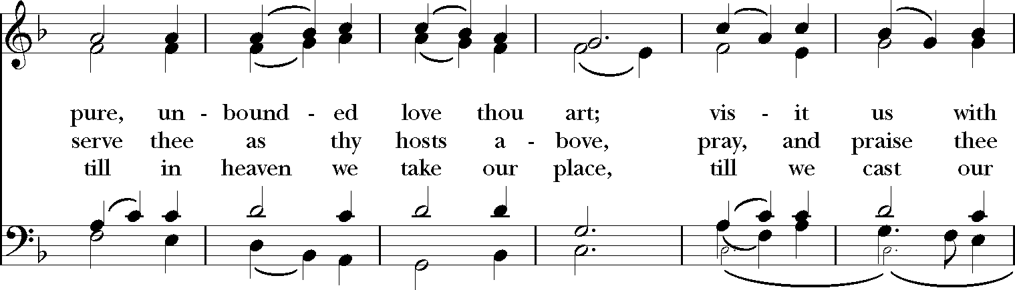
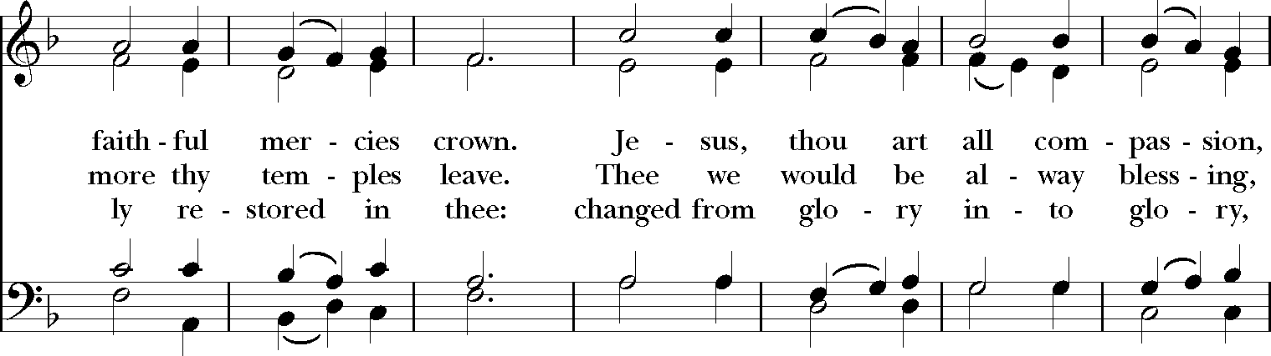
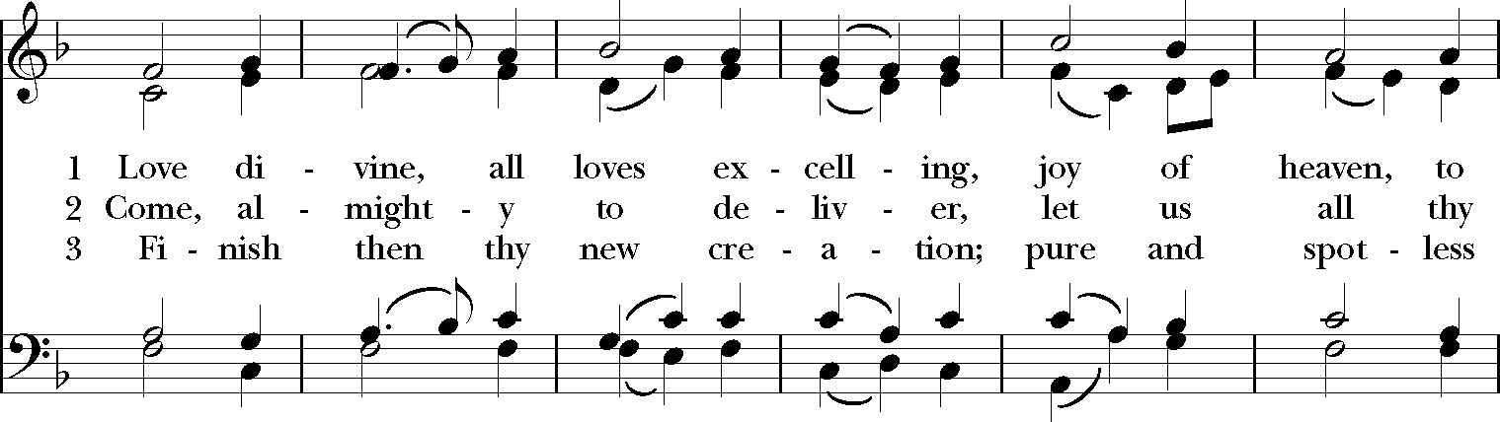
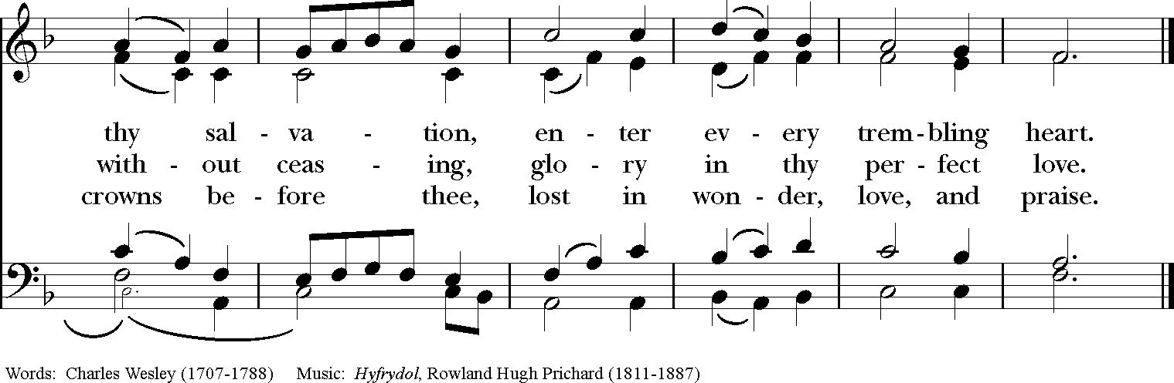
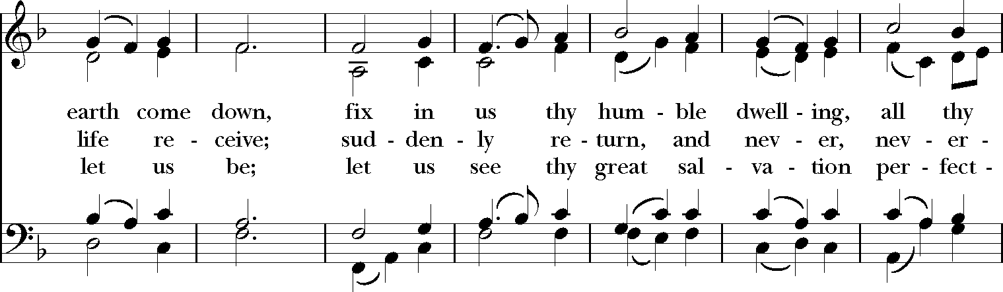

Officiant Alleluia, alleluia. Let us bless the Lord.
People Thanks be to God. Alleluia, alleluia.

Officiant
Glory to God whose power, working in us, can do infinitely more than we can ask or imagine: Glory to God from generation to generation in the Church, and in Christ Jesus for ever and ever. Amen.

Postlude Felix Mendelssohn
Allegro maestoso e vivace from Sonata No. 4 in Bb Major

Worship Leaders
Officiant The Rev. Marissa Rohrbach
Preacher The Rev. Dr. Molly James
Lectors Brian Angerame, Adair Garis, Anne Newton, Sharon Pearson,
Samantha Trolice
Parish Choir
Coffee Hour Hosts Pam Ely
Facebook Greeter Pam Ely

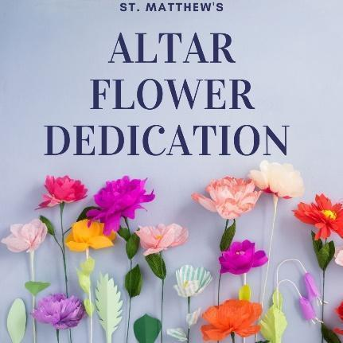

Flowers
The altar flowers are given in loving memory of Emily Walke Woodside by her children, Bill, Sam and Anne Woodside.

Prayer Requests Specific prayer requests will be kept on the prayer list for six weeks. Please call or email the office if you have additions or deletions to the prayer list. You are encouraged to offer your own prayers silently or aloud as indicated in the Prayers of the People.

Today and through the week, we remember all those who have been commended to our prayers. For those who are sick or in need: Courtney, Anderson, Vinny, Ann, Bruce, Melinda, Carolann, Rob, David, Jane, MaryAnn, Roy, Christine, Rich, Nancy, Ken, Dawn, Donnie, David, James, Jeff, Aaron, Michael, Katie, Petra, Doris, Patricia, Frank, Gene, Bo, Kathy, Geoff, Richard Douthitt, Mary Lou Mannix, Charles Kennedy and Dann Pompa. For those serving in the military, Jake Walker and Matthew Comeau.

In the Diocesan Cycle of Prayer, we pray for St. Mark’s, New Britain; St. Mark’s, New Canaan; Christ Church, New Haven. Parish prayer groups; intercessory prayer chains; healing prayer groups, and parish and community bible studies

Altar Flower Dedications
You can celebrate or memorialize your loved ones with flower dedications. Let us know the date you would like and any colors or flowers you want (we will do our best) and the Flower Guild will make a beautiful vase arrangement and delivery to your home (local addresses only please). We will announce the dedication in church and on our social media. A $75 donation is suggested.
Please email Jennifer Angerame at theangerames@gmail.com with questions.
Join Us For Coffee Hour – Sundays at 9am
This fall, coffee hour returns in a slightly different form! Join us on Sunday mornings at 9am. Gather with other parishioners for an hour before virtual worship at 10am. Bring your coffee or tea and spend some time connecting with all those faces you miss! To begin, Coffee Hour will be hosted each week by our Vestry members and Officers. As we move further into the year, there will be opportunities for others to host as well. As always, Zoom information will be shared in our e-News and will be posted in our Parishioner Facebook Group. We can't wait to see you!

Join us in a Zoom room for Sung Compline –
Tuesday at 9pm
We will share our last Compline of the season together this week on May 11th. Please join us for the last time this season and help us to thank our talented musicians for their leadership. When Andrew arrives, we'll work together to assess Compline and other worship and music opportunities for the fall!

Evening Prayer at St. Matthew’s – All Are Invited
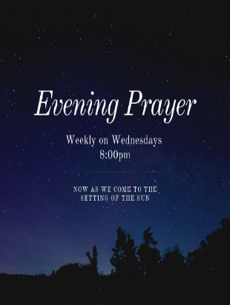
Set aside your Wednesday evenings as a family (or after the kids go to bed) to join St. Matthew’s for online Evening Prayer to end the day. Offered via Zoom, this short (15-20 minute) service will help you settle down after a long day, giving thanks for what has been done and what has been left undone. Starting at 8:00pm led by members of St. Matt’s, we will begin by greeting one another then move into prayer with the opportunity for anyone to contribute or ask for prayers during the service. A link will be provided each week in our eNews and our Parishioner Facebook Group.

Join the Conversation – A Closer look at the Sunday Gospel
As an outgrowth of our 2020 Spiritual Inventory survey, the Renewal Works team is offering two opportunities each week, for parishioners to gather and discuss what we heard on Sunday in the Gospel and the Sermon. What jumped out at you? What confused you? How might it touch your day-to-day life? What did other parishioners hear?

This 6-week “drop-in” series (i.e., no homework!) will provide parishioners an opportunity to review the Gospel passage from Sunday and dig a little deeper into it. Starting at either 11:30am on Sundays, or 9:30am on Mondays, come with your coffee to explore what the Gospel is saying to each of us and how Marissa’s sermons add to our understanding. Two Renewal Works team members will facilitate the conversation each week to help guide our discussion. So, invite a friend and join us (virtually) for an hour of fellowship and exploration. The lectionary calendar which we will follow for our discussions is below:

Week 1 (April 25, 26): John 10:11-18
Week 2: (May 2, 3): John 15:1-8
Week 3: (May 9, 10): John 15:9-17
Week 4: (May 16, 17): John 17:6-19
Week 5: (May 23, 24): John 15:26-27; 16:4b-15
(skip Memorial Day weekend)
Week 6: (June 6, 7): Mark 3:20-35

For more information, or if you have questions, you can reach out to Pam Carlson or
Joe Magnano.

Weekly Calendar – May 9 – May 16

Sunday, May 9 The Sixth Sunday of Easter
9:00am Coffee Hour (Zoom)
10:00am Morning Prayer (Livestream)
11:30am Sunday Gospel Group Discussion (Zoom)

Monday, May 10
9:30am Sunday Gospel Group Discussion (Zoom)
7:00pm Education for Ministry (Zoom)

Tuesday, May 11
11:00am Staff Meeting (Zoom)
9:00pm Compline (Zoom)

Wednesday, May 12
8:00pm Evening Prayer (Zoom)

Thursday, May 13
7:30pm Online Adult & Youth Choir rehearsal

Sunday, May 16 The Seventh Sunday of Easter
9:00am Coffee Hour (Zoom)
9:00am Church School Grades K-5 (Zoom)
10:00am Holy Eucharist – Rite 2 (Livestream)
11:30am Sunday Gospel Group Discussion (Zoom)

Connection details available on our website, in the e-news, and in our Parishioner Facebook group. Need to sign up for the e-news? It’s easy – just go to www.stmatthewswilton.org/newsletter.

Need to join the Parishioner Facebook Group? Go here: https://www.facebook.com/groups/StMatthewsOnline/

Need something else? Send Marissa a note or be in touch with another member of the staff.

Next Week: Worship online again with St. Matthew’s
There are many ways to connect with St. Matt’s in the coming weeks. Please keep an eye on our website and social media as well as our e-news. There you’ll find information and opportunities to connect for friends and members of all ages.
_________________________________________________________

Staff
Rector The Rev. Marissa S. Rohrbach, marissa@stmatthewswilton.org
Deacon The Rev. Deacon Don Burr, don@stmatthewswilton.org
Parish Administrator Nancy Johnson, office@stmatthewswilton.org
Children, Youth & Family Samantha Trolice, samantha@stmatthewswilton.org
WEPCO Facilities Coordinator Andrew Arevalo, wepco@optonline.net
Bookkeeper Louann Miska, louann.miska@gmail.com
Nursery Staff Lucia Sato, Kate DeAngelis
Sexton Max Gil

Wardens and Officers
Sr. Warden Brian Angerame Asst. Treasurers Bruce Beebe, Andrea Sato
Jr. Warden Pam Ely Clerk Anne Newton
Treasurer Keith DeAngelis

The Vestry
Vytas Kisielius Pam Carlson Joe Magnano
Dodo Roberts Tim Jarvis Paul Reis
Jessica Christ

36 New Canaan Road, Wilton, CT 06897
Phone: (203) 762-7400
www.stmatthewswilton.org
Like us on Facebook! www.facebook.com/stmattswilton
Follow us on Twitter & Instagram @stmattswilton

