Holy Baptism - Rite II
The Feast of St. Mary Magdalene
October 2nd, 2022
10:00 am
Welcome to St. Matthew's! We are glad you are here.
The People are invited to read the words in bold. If you’re joining us from home, please stand, kneel, sing, and pray with us as you’re able. No matter where you are, joining in this worship service is a form of prayer that connects you to God and to each other. Whenever two or three are gathered, even virtually, Scripture reminds us that Jesus is present among us.

Children are most welcome and are encouraged to participate in worship.
To the parents of children: Relax! God put the wiggle in children. Sit toward the front so your little ones can see and hear. Go ahead and quietly answer their questions. If you don’t know the answer, the priest would love to talk to your little one. When you sing the hymns and join in the prayers, you teach little hearts how to be faithful; you are their best model. If you need to leave the service, that’s okay. Don’t be shy about coming back. It was Jesus who said, “Let the little children come to me.”

Wherever you are on your spiritual journey, there is a place for you at St. Matt's.

+ T H E W O R D O F G O D +

Bagpipe Prelude

Prelude John G. Barr (b. 1938)
Prelude on "The Church's one foundation"
The hymns can be found in the blue hymnals. Please stand as you are able.
Processional Hymn 525 Aurelia
“The Church’s one foundation”

Celebrant Blessed by God: Father, Son, and Holy Spirit.
People And blessed be God’s kingdom, now and for ever. Amen.

Celebrant There is one Body and one Spirit;
People There is one hope in God’s call to us;
Celebrant One Lord, one Faith, one Baptism;
People One God and Father of all.

Celebrant The Lord be with you.
People And also with you.
Celebrant Let us pray. Almighty God, whose blessed Son called Mary Magdalene to be a witness of his resurrection: Mercifully grant that by your grace we may know you in the power of his unending life; who with you and the Holy Spirit lives and reigns, one God, now and for ever. Amen.

The congregation is seated.

The First Reading Jeremiah 1:4-10
The word of the Lord came to me saying,
"Before I formed you in the womb I knew you,
and before you were born I consecrated you;
I appointed you a prophet to the nations."
Then I said, "Ah, Lord God! Truly I do not know how to speak, for I am only a boy." But the Lord said to me,
"Do not say, 'I am only a boy';
for you shall go to all to whom I send you,
and you shall speak whatever I command you,
Do not be afraid of them,
for I am with you to deliver you, says the Lord."
Then the Lord put out his hand and touched my mouth; and the Lord said to me,
"Now I have put my words in your mouth.
See, today I appoint you over nations and over kingdoms,
to pluck up and to pull down,
to destroy and to overthrow,
to build and to plant."

Lector The Word of the Lord.
People Thanks be to God.

Psalm 42:1-7 sung by the Choir

¹ As the deer longs for the water-brooks, *
so longs my soul for you, O God.

² My soul is athirst for God, athirst for the living God; *
when shall I come to appear before the presence of God?

³ My tears have been my food day and night, *
while all day long they say to me,
"Where now is your God?"

⁴ I pour out my soul when I think on these things: *
how I went with the multitude and led them into the house of God,

⁵ With the voice of praise and thanksgiving, *
among those who keep holy-day.

⁶ Why are you so full of heaviness, O my soul? *
and why are you so disquieted within me?

⁷ Put your trust in God; *
for I will yet give thanks to him,
who is the help of my countenance, and my God.

The Second Reading 2 Corinthians 5:14-18
The love of Christ urges us on, because we are convinced that one has died for all; therefore all have died. And he died for all, so that those who live might live no longer for themselves, but for him who died and was raised for them.
From now on, therefore, we regard no one from a human point of view; even though we once knew Christ from a human point of view, we know him no longer in that way. So if anyone is in Christ, there is a new creation: everything old has passed away; see, everything has become new! All this is from God, who reconciled us to himself through Christ, and has given us the ministry of reconciliation.

Lector The Word of the Lord.
People Thanks be to God.

Please stand as you are able.

Sequence Hymn 490 Houston
“I want to walk as a child of the light”

Children in Pre-K – 7th Grade may proceed to their classrooms for
Church School at the beginning of the first verse.

The Holy Gospel John 20:11-18
Celebrant The Holy Gospel of our Lord Jesus Christ, according to John.
People Glory to you, Lord Christ.

Mary stood weeping outside the tomb. As she wept, she bent over to look into the tomb; and she saw two angels in white, sitting where the body of Jesus had been lying, one at the head and the other at the feet. They said to her, “Woman, why are you weeping?” She said to them, “They have taken away my Lord, and I do not know where they have laid him.” When she had said this, she turned around and saw Jesus standing there, but she did not know that it was Jesus. Jesus said to her, “Woman, why are you weeping? Whom are you looking for?” Supposing him to be the gardener, she said to him, “Sir, if you have carried him away, tell me where you have laid him, and I will take him away.” Jesus said to her, “Mary!” She turned and said to him in Hebrew, “Rabbouni!” (which means Teacher). Jesus said to her, “Do not hold on to me, because I have not yet ascended to the Father. But go to my brothers and say to them, ‘I am ascending to my Father and your Father, to my God and your God.’” Mary Magdalene went and announced to the disciples, “I have seen the Lord”; and she told them that he had said these things to her.

Celebrant The Gospel of the Lord.
People Praise to you, Lord Christ.

The Sermon The Rev. Julie V. Kelsey

All stand to sing.
Baptismal Hymn 296 Engelberg
“We know that Christ is raised and dies no more”

The Presentation and Examination of the Candidate
Celebrant
The Candidate for Holy Baptism will now be presented.

Parents and Godparents
We present Laine Madeleine to receive the Sacrament of Baptism.

Celebrant
Will you be responsible for seeing that the child you present is brought up in
the Christian faith and life?

Parents and Godparents
I will, with God’s help.

Celebrant
Will you by your prayers and witness help this child to grow into the full
stature of Christ?

Parents and Godparents
I will, with God’s help.

The Celebrant asks the parents and Godparents the following questions:

Question Do you renounce Satan and all the spiritual forces of wickedness that rebel against God?
Answer I renounce them.

Question Do you renounce the evil powers of this world which corrupt and destroy the creatures of God?
Answer I renounce them.

Question Do you renounce all sinful desires that draw you from the love of God?
Answer I renounce them.

Question Do you turn to Jesus Christ and accept him as your Savior?
Answer I do.

Question Do you put your whole trust in his grace and love?
Answer I do.

Question Do you promise to follow and obey him as your Lord?
Answer I do.

Then the Celebrant addresses the congregation, saying
Will you who witness these vows do all in your power to support this child
in her life in Christ?

People We will.

The Celebrant then says
Let us join with Laine, and her parents and Godparents who are committing themselves to Christ as we renew our own baptismal covenant.

The Baptismal Covenant
Celebrant Do you believe in God the Father?
People I believe in God, the Father almighty,
creator of heaven and earth.

Celebrant Do you believe in Jesus Christ, the Son of God?
People I believe in Jesus Christ, his only Son, our Lord.
He was conceived by the power of the Holy Spirit and born of the Virgin Mary.
He suffered under Pontius Pilate, was crucified, died, and was buried. He descended to the dead.
On the third day he rose again.
He ascended into heaven, and is seated at the right hand of the Father.
He will come again to judge the living and the dead.

Celebrant Do you believe in God the Holy Spirit?
People I believe in the Holy Spirit, the holy catholic Church, the communion of saints, the forgiveness of sins,
the resurrection of the body,
and the life everlasting.

Celebrant Will you continue in the apostles’ teaching and fellowship, in the breaking of bread, and in the prayers?
People I will, with God’s help.

Celebrant Will you persevere in resisting evil, and, whenever you fall into sin, repent and return to the Lord?
People I will, with God’s help.

Celebrant Will you proclaim by word and example the Good News of God in Christ?
People I will, with God’s help.

Celebrant Will you seek and serve Christ in all persons, loving your neighbor as yourself?
People I will, with God’s help.

Celebrant Will you strive for justice and peace among all people, and respect the dignity of every human being?
People I will, with God’s help.

Prayers for the Candidate
Leader Deliver her, O Lord, from the way of sin and death.
People Lord, hear our prayer.

Leader Open her heart to your grace and truth.
People Lord, hear our prayer.

Leader Fill her with your holy and life-giving Spirit.
People Lord, hear our prayer.

Leader Keep her in the faith and communion of your holy Church.
People Lord, hear our prayer.

Leader Teach her to love others in the power of the Spirit.
People Lord, hear our prayer.

Leader Send her into the world in witness to your love.
People Lord, hear our prayer.

Leader Bring her to the fullness of your peace and glory.
People Lord, hear our prayer.

Silence may be kept.

The Celebrant concludes
We pray for Lyn and Marissa, Laine’s parents, and Olivia, Laura, Rachel, Sue, and Jessica who have taken vows as Godparents. Gracious God, make each of them strong and faithful in the promises they have made this day.

Grant, O Lord, that all who are baptized into the death of Jesus Christ your Son may live in the power of his resurrection and look for him to come again in glory; who lives and reigns now and forever. Amen.

Thanksgiving over the Water
The Celebrant blesses the water, first saying
The Lord be with you.
People And also with you.

Celebrant Let us give thanks to the Lord our God.
People It is right to give God thanks and praise.

Celebrant
We thank you, Almighty God, for the gift of water. Over it the Holy Spirit moved in the beginning of creation. Through it you led the children of Israel out of their bondage in Egypt into the land of promise. In it your Son Jesus received the baptism of John and was anointed by the Holy Spirit as the Messiah, the Christ, to lead us, through his death and resurrection, from the bondage of sin into everlasting life.

We thank you, Father, for the water of Baptism. In it we are buried with Christ in his death. By it we share in his resurrection. Through it we are reborn by the Holy Spirit. Therefore, in joyful obedience to your Son, we bring into his fellowship those who come to him in faith, baptizing them in the Name of the Father, and of the Son, and of the Holy Spirit.

At the following words, the Celebrant touches the water
Now sanctify this water, we pray you, by the power of your Holy Spirit, that those who here are cleansed from sin and born again may continue for ever in the risen life of Jesus Christ our Savior. To him, to you, and to the Holy Spirit, be all honor and glory, now and for ever. Amen.

The Baptism
The Priest says
Laine Madeleine, I baptize you in the Name of the Father, and of the Son, and of the Holy Spirit. Amen.

Then the Priest places a hand on the child’s head, marking on the forehead the sign of the cross using the Chrism and saying
Laine Madeleine, you are sealed by the Holy Spirit in Baptism and marked as Christ’s own for ever. Amen.

The Celebrant continues
Let us pray.

Heavenly Father, we thank you that by water and the Holy Spirit you have bestowed upon this your servant the forgiveness of sin, and have raised her to the new life of grace. Sustain her, O Lord, in your Holy Spirit. Give her an inquiring and discerning heart, the courage to will and to persevere, a spirit to know and to love you, and the gift of joy and wonder in all your works. Amen.

Then the Parents and Godparents are presented with a candle, lit from the Pascal candle,
Marissa and Lyn, Laura, Rachel, Jessica, Sue, and Olivia, receive this light on behalf of Laine and help her to shine in this world with the light of Christ.

Celebrant Let us welcome the newly baptized.
People We receive you into the household of God. Confess the faith
of Christ crucified, proclaim his resurrection, and share with
us in his eternal priesthood.

Choral Benediction Peter C. Lutkin (1858–1931)
The Lord bless you and keep you. The Lord lift His countenance upon you; And give you peace. The Lord make His face to shine upon you. And be gracious unto you. Amen.

The Peace
Celebrant The peace of the Lord be always with you.
People And also with you.

+ T H E H O L Y C O M M U N I O N +

Celebrant says an Offertory sentence, the congregation is seated.
Walk in love, as Christ loved us and gave himself for us, an offering and sacrifice to God.

Offertory Anthem Giovanni Pierluigi da Palestrina (1525–94)

Sicut cervus
Sicut cervus desiderat ad fontes aquarum, As the deer longs for the water-brooks,
ita desiderat anima mea ad Te, Deus. so longs my soul for you, O God.
— Psalm 42:1

Whether you’ve joined us today from near or far, in person or online, please consider making a gift of thanksgiving to support the work of God at St. Matthew’s. Be part of God’s mission with us

as we make our way out of the COVID season and into the new life God promises.

Visit www.stmatthewswilton.org/offering. Designate it as a gift or as part of your pledge.

No gift is too small. All gifts honor the God who honors us with life, breath, love, and salvation.

Please stand as you are able.

Doxology at the Presentation sung by all The Old Hundredth

Praise God from whom all blessings flow,
Praise God all creatures here below,
Praise God above ye heavenly host;
praise Father, Son, and Holy Ghost. Amen.
The Great Thanksgiving
Celebrant The Lord be with you.
People And also with you.
Celebrant Lift up your hearts.
People We lift them to the Lord.
Celebrant Let us give thanks to the Lord our God.
People It is right to give our thanks and praise.

It is truly right, and good and joyful to give you thanks, all-holy God, source of life and fountain of mercy. Because in Jesus Christ our Lord you have received us as your children, made us citizens of your kingdom, and given us the Holy Spirit to guide us into all truth.

Therefore, joining with Angels and Archangels and with the faithful of every generation we lift our voices with all creation as we sing:

Sanctus – S129 Sung by all setting by Robert Powell (b. 1932)

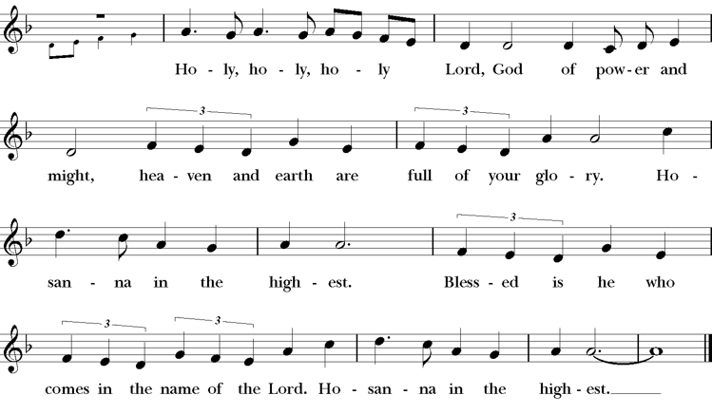
The people remain standing or kneel. The Celebrant continues
Blessed are you, Gracious God, creator of the universe and giver life. You formed us in your own image and called us to dwell in your infinite love.

You gave the world into our care that we might be your faithful stewards and show forth your bountiful grace. But we failed to honor you image in one another and in ourselves; we would not see your goodness in the world around us; and so we violated your creation, abused one another, and rejected your love. Yet you never ceased to care for us, and prepared the way of salvation for all people.

Through Abraham and Sarah you called us into covenant with you. You delivered us from slavery, sustained us in the wilderness, and raised up prophets to renew your promise of salvation. Then, in the fullness of time, you sent your eternal Word made mortal flesh in Jesus.

Born into the human family and dwelling among us, he revealed your glory. Giving himself freely to death on the cross, he triumphed over evil, opening the way of freedom and life.

On the night before he died for us, our Savior Jesus Christ took bread, and when he had given thanks to you, he broke it, and gave it to his friends, and said: “Take, eat: This is my Body which is given for you. Do this for the remembrance of me.”

As supper was ending, Jesus took the cup of wine, and when he had given thanks, he gave it to them, and said: “Drink this, all of you: This is my Blood of the new Covenant, which is poured out for you and for all for the forgiveness of sins. Whenever you drink it, do this for the remembrance of me.”

Therefore we proclaim the mystery of faith:

Celebrant and People say together
Christ has died.
Christ is risen.
Christ will come again.

Remembering his death and resurrection, we now present to you from your creation this bread and this wine. By your Holy Spirit may they be for us the Body and Blood of our Savior Jesus Christ. Grant that we who share these gifts may be filled with the Holy Spirit and live as Christ’s Body in the world.

Bring us into the everlasting heritage of your daughters and son, that with Mary Magdalene, and Mary the Mother of Jesus, and all your saints, past, present, and yet to come, we may praise your Name for ever.

Through Christ and with Christ and in Christ, in the unity of the Holy Spirit, to you be honor, glory, and praise, for ever and ever. AMEN.

And now, as our Savior Christ has taught us, we are bold to say,
Celebrant and People
Our Father, who art in heaven, hallowed be thy Name, thy kingdom come, thy will be done, on earth as it is in heaven. Give us this day our daily bread. And forgive us our trespasses, as we forgive those who trespass against us. And lead us not into temptation, but deliver us from evil. For thine is the kingdom, and the power, and the glory for ever and ever. Amen.

The Breaking of the Bread
The Celebrant breaks the consecrated Bread. A period of silence is kept.

Celebrant Alleluia, Christ our Passover is sacrificed for us;
People Therefore let us keep the feast. Alleluia.
Fraction Anthem – S169 Sung by all setting by Ray W. Urwin (b. 1950)

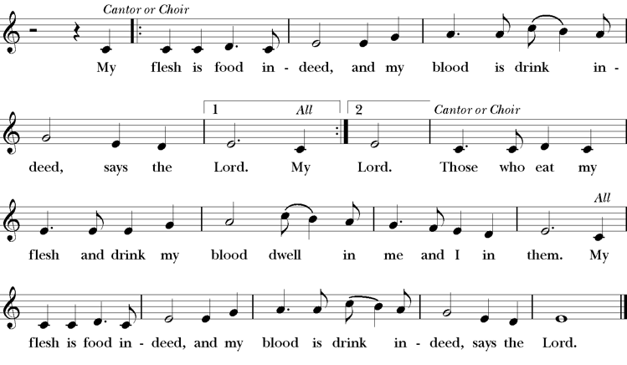

The Celebrant says the following Invitation
The Gifts of God for the People of God. Take them in remembrance that Christ died for you, and feed on him in your hearts by faith, with thanksgiving.

All are welcome to come forward, as directed by ushers, to receive communion or a blessing. The Ushers will help you move toward the center in single file, socially distanced lines. When you reach the center of the space, please open your
hands and lay them flat to receive the bread or cross your arms over your chest to receive a blessing.
Let the Priest know if you need a gluten free wafer by first extending your palms down.
After you receive the bread or a blessing, you may make your way back to your pew.
If you would like to have communion brought to your pew, please let an usher know.

The People may remain seated to sing the communion hymns.
Communion Hymn 335 I am the Bread of Life
“I am the bread of life”

Communion Hymn “Softly and tenderly Jesus is calling”
All sing.

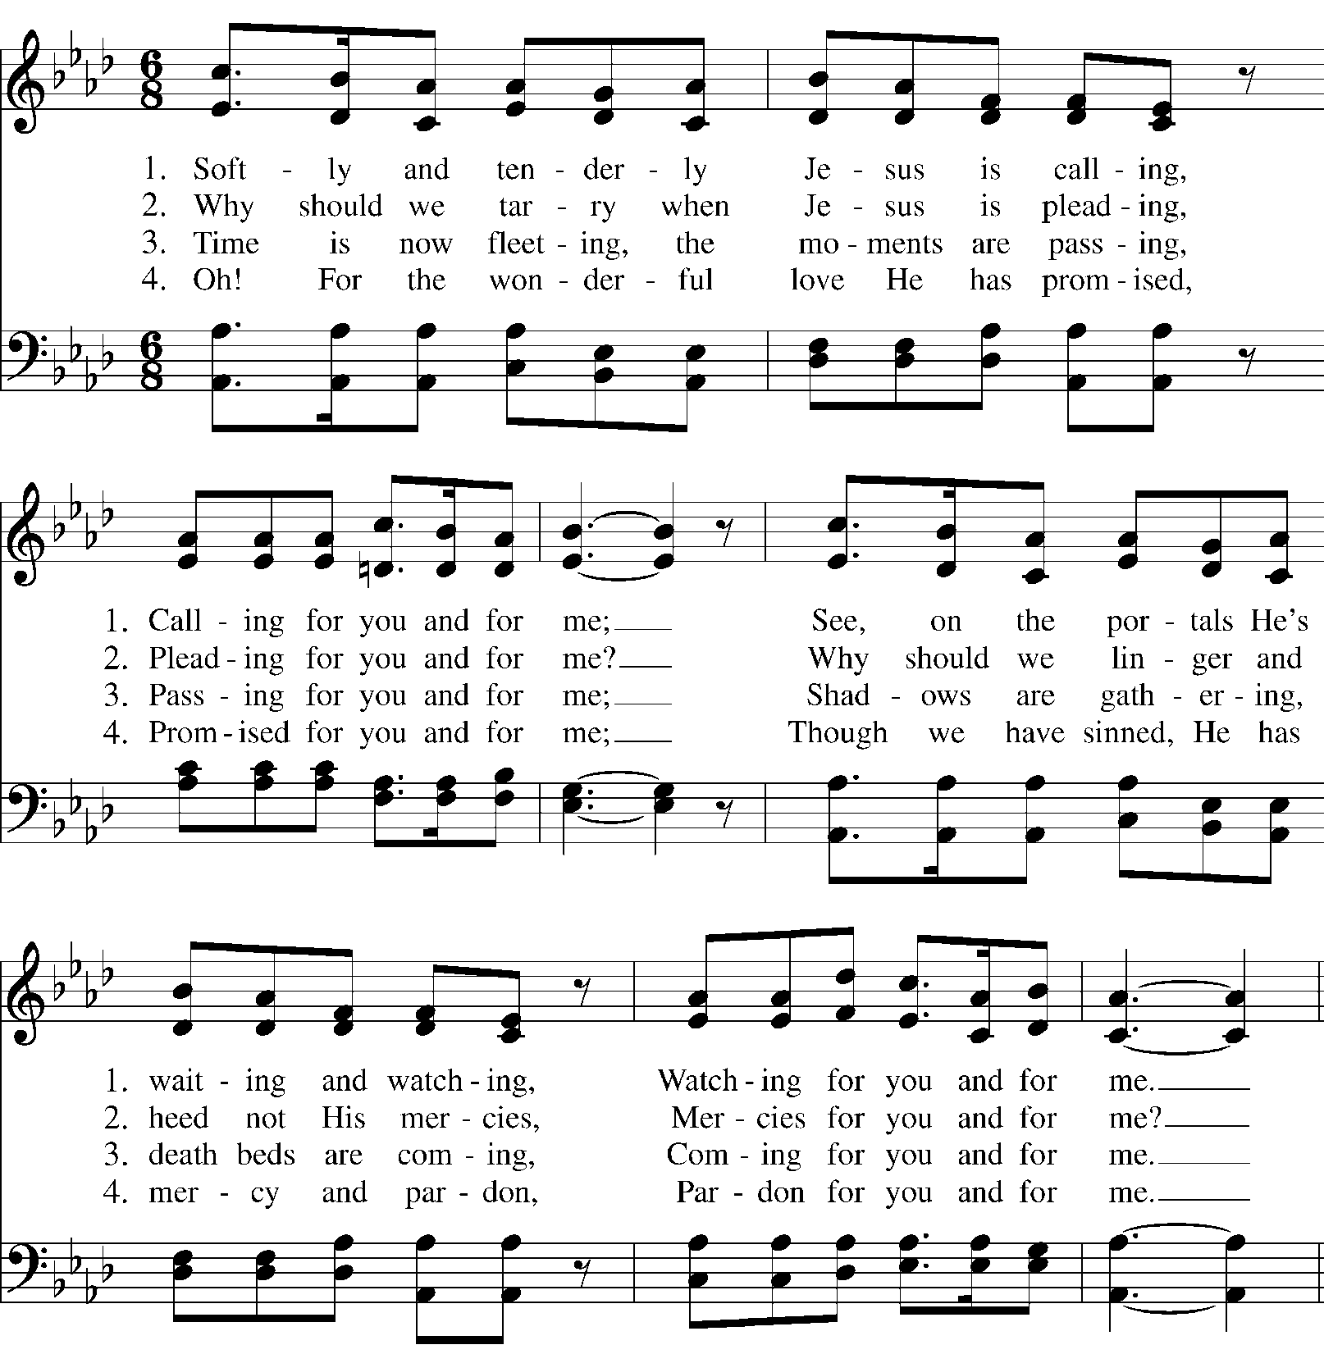

If you are joining from home or have not received communion, you may offer this prayer to the Lord.

The Act of Reception Saint Augustine’s Prayer Book (2nd ed)
The Celebrant and the People say together
In union, Blessed Jesus, with the faithful gathered at every altar of your Church where your blessed Body and Blood are offered this day, I long to offer you praise and thanksgiving, for creation and all the blessings of this life, for the redemption won for us by your life, death, and resurrection, for the means of grace and the hope of glory.

I believe that you are truly present in the Holy Sacrament, and, since I cannot at this time receive communion, I pray you to come into my heart. I unite myself with you and embrace you with all my heart, my soul, and my mind. Let nothing separate me from you; let me serve you in this life until, by your grace, I come to your glorious kingdom and unending peace.

Come Lord Jesus, and dwell in my heart in the fullness of your strength; be my wisdom and guide me in right pathways; conform my life and actions to the image of your holiness; and, in the power of your gracious might, rule over every hostile power that threatens or disturbs the growth of your kingdom, who with the Father and the Holy Spirit, lives and reigns, one God, in glory everlasting. Amen.

The Postcommunion Prayer
The People stand or kneel.
Celebrant Let us pray.
People Loving God, we give you thanks for restoring us in your image and nourishing us with spiritual food in the Sacrament of Christ’s Body and Blood. Now send us forth a people, forgiven, healed, renewed; that we may proclaim your love to the world and continue in the risen life of Christ our Savior. Amen.

Parish Announcements

The Blessing
The Celebrant blesses the People
The Wisdom of God, the Love of God, and the Grace of God give you strength to be Christ’s hands and heart in this world. And the blessing of God Almighty, who creates, redeems, and sanctifies be with you this day and always. Amen.

Recessional Hymn “How Great Thou Art”
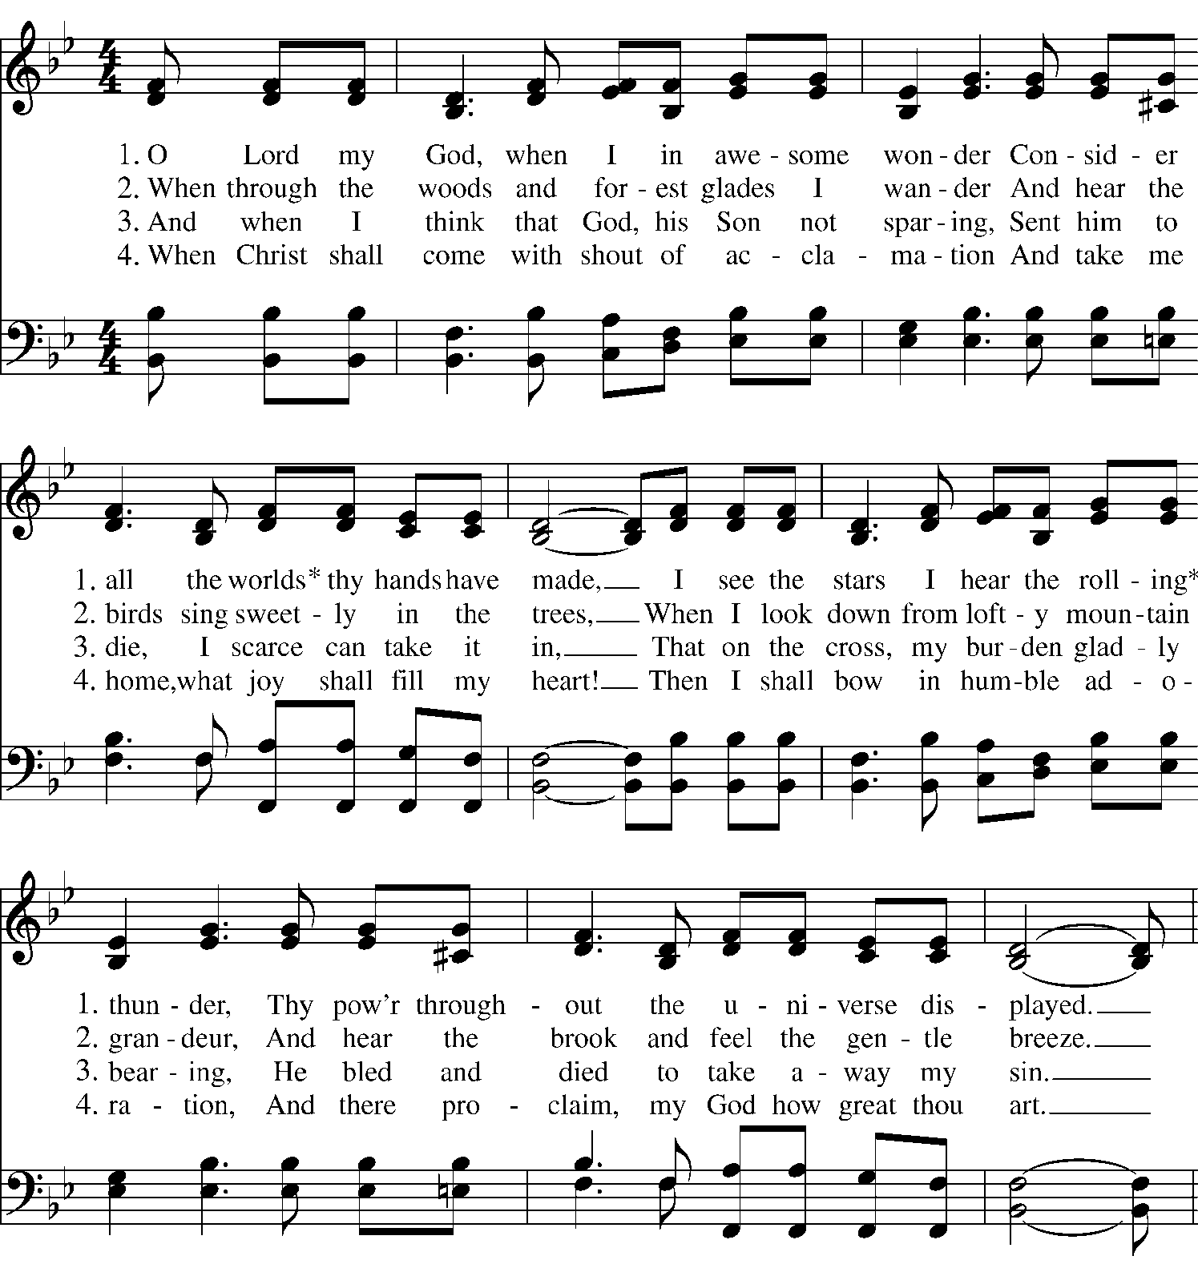

The Celebrant offers the dismissal to which the people respond,
Celebrant Alleluia! Alleluia! Go in peace to love and serve the Lord.
People Thanks be to God. Alleluia! Alleluia!

Bagpipe Postlude

Worship Leaders
Celebrants The Rev. Julie V. Kelsey, The Rev. Jessica E. Sexton,
The Rev. Marissa S. Rohrbach
Preacher The Rev. Julie V. Kelsey
Lectors Karen Geller, Jean Campbell
Intercessor Lyn Rossano
Crucifer Pam Ely
Eucharistic Ministers Anne Newton, Sharon Pearson
Ushers Keith DeAngelis, David Gortz, and Chris Perry
Music Director Andrew Leslie Cooper
Choir St. Matthew’s Church Choir
Bagpiper Al Gonzales
Counters David Gortz, Rob Kyle

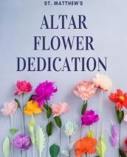
Today’s altar flowers are given to the glory of God and in thanksgiving for the baptism into new life of Laine Madeleine Rossano Rohrbach by the Rev. & Mrs. Rohrbach.

Prayer Requests Specific prayer requests will be kept on the prayer list for six weeks. Please call or email the office if you have additions or deletions to the prayer list. You are encouraged to offer your own prayers silently or aloud as indicated in the Prayers of the People.

Today and through the week, we remember all those who have been commended to our prayers. For those who are sick or in need: Kelly, Bill, Parker, Andy, Liz, Ann, Jose, Jim, Jack, Pat, Donald, Alison, Laura, Dick, Jackie, Tom, Michael, Joanne, Brooks, Scott, Bobby, Martin, Vinny, Ann, Bruce, Melinda, Rob, Jane, Nancy, Dawn, Donnie, David, Aaron, Petra, Kathy, Richard Douthitt, Mary Lou Mannix, Charles Kennedy and Dann Pompa. For those serving in the military, Matthew Comeau.

In the Diocesan Cycle of Prayer, we pray for the Consecration of the XVI Bishop Diocesan of the Episcopal Church in Connecticut on October 15, 2022.

Mission Update
This fall St. Matthew’s has two opportunities to engage with our mission partners. First, in October we will be hosting children and parents from Open Doors to the town’s Halloween parade. We will be collecting costumes for the children to wear as soon as we know their sizes and perhaps their favorite super hero too! And second, we’ll be collecting gifts for the Circle of Care children in November. A list will be posted of their favorite toys and gifts. You can read more about both opportunities in the weekly eNews. Any questions or if you would like to be part of these two mission opportunities, please contact Pam Ely.

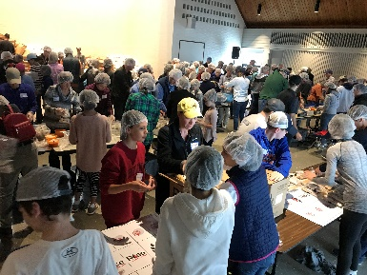
Wi-ACT’s Rise Against Hunger Meal-Packaging Event: Saturday, October 22nd
Wi-ACT’s on-line registration site for this event specifically for St. Matthew’s parishioners is available on the St. Matthew’s website. More information can be found in the weekly eNews.

Exploring the Doctrine of Discovery
Several members of St. Matthew’s Social Justice & Racial Healing group will be participating in an online course that was created for Episcopalians that live in New England and led by the Rt. Rev. Carol Gallagher, a member of the Cherokee tribe who serves in the Diocese of Massachusetts. Perhaps you’d be interested in taking the course also! Through your journey in a multi-media web quest, you will find out the thinking behind the Doctrine of Discovery, how it was justified by Christian church leaders, what happened to the people it touched, how it continues to affect Indigenous people worldwide today, and what hope there is for Indigenous people in the future. You will hear Indigenous voices again and again, something that is unusual in Doctrine of Discovery courses. You will learn how the connection with the land and with Creator has given Indigenous people the spiritual resilience we have today as survivors of the Doctrine of Discovery. “Talking Circles” will be held on Sundays from 4:00-5:30 pm ET on October 2, 9, 16, 23, and 30 (synchronously). Videos and articles can be accessed on your own time and pace (asynchronously). To learn more or register contact Sharon Pearson or any member of the SJ&RH Team.
Join Our Digital Ministry Team!
There are many ways to get involved in the life of St. Matthew's and here is a brand new one! We are starting a digital ministry whose main focus is live-streaming the our Sunday services. It's quite an exciting way to experience worship on Sunday morning. We will provide full training and shadowing to ensure you are equipped and comfortable before you jump in on your own. If you are interested, please email Samantha@stmatthewswilton.org and set up a time to discuss and/or train.

St. Matt’s Spirited Sisters
Introducing a new women’s group at St. Matthew’s! Our goal is to build a community of faith for the women of St. Matthew’s by exploring and strengthening our Christian ideals and knowledge, fostering friendship, offering prayer and support for each other, and building a deeper relationship with Christ. We will meet monthly to discuss topics of faith by listening to podcasts, reading articles, taking field trips and learning from each other. We welcome all of the women of St. Matthew’s and their friends. Discussion materials will be available prior to meeting, but advanced prep work is not required. Any questions or for more information, contact Pam Carlson or Stacey Savas.

Weekly Calendar – October 2 – October 9

Sunday, October 2 The Seventeenth Sunday after Pentecost
10:00am Holy Baptism – Rite II- (In person & Livestream)
10:15am Church School
11:30-1:00pm Joint High School Youth Group

Monday, October 3
7:00-9:00pm Education for Ministry

Tuesday, October 4
11:00 am Staff meeting
7:00-9:00pm Finance Committee meeting

Wednesday, October 5
8:30am-4:30pm 6th-12th Grade Youth Retreat

Thursday, October 6
3:30-4:30pm 9th-12th Grade Book Group discussion
7:30pm-9:00pm St. Matthew’s Church Choir rehearsal

Sunday, October 9 The Eighteenth Sunday after Pentecost
10:00am Holy Eucharist – Rite 2 - (In person & Livestream)
10:15am Church School

Worship Schedule at St. Matthew’s
Holy Eucharist on Sundays at 10am

Please keep an eye on our website and social media as well as our e-news. There you’ll find information and opportunities to connect for friends and members of all ages.

Staff
Rector The Rev. Marissa S. Rohrbach, marissa@stmatthewswilton.org
Music Ministries & Organist Andrew Leslie Cooper, andrew@stmatthewswilton.org
Parish Administrator Nancy Johnson, office@stmatthewswilton.org
Children, Youth & Family Samantha Trolice, samantha@stmatthewswilton.org
WEPCO Facilities Coordinator Andrew Arevalo, wepco@optonline.net
Bookkeeper Louann Miska, louann.miska@gmail.com
Media Technician Matthew Henshaw Nursery Staff Lucia Sato
Sexton Max Gil

Wardens and Officers
Warden Pam Ely Clerk Jennifer DeAngelis
Warden Anne Newton Asst. Treasurers Andrea Sato, Rob Kyle
Treasurer Keith DeAngelis

The Vestry
Beth Baker Amy Gubner Joe Magnano
Pam Carlson Vytas Kisielius Paul Reis

36 New Canaan Road, Wilton, CT 06897
Phone: (203) 762-7400
www.stmatthewswilton.org
Like us on Facebook! www.facebook.com/stmattswilton
Follow us on Twitter & Instagram @stmattswilton

